2023

Noms des participants :

Chennit Zineb

Bentebbal Sabrine

Djabella Lounes

Bentafat Wail

Daghboudj Hba

28/12/2023



Report on Information and Communication Technologies (TIC) and Related Technologies

Information and communication technologies

1: Introduction

Information and Communication Technologies (ICT) encompass a diverse set of technologies that play a crucial role in shaping how we communicate, work, and access information in our modern society

* Exploring ICT

Picture a world where tools, devices, and applications come together to facilitate the creation, manipulation, storage, and transmission of information in various forms such as text, images, sound, and video. This is where Information and Communication Technologies (ICT) come into play, spanning a wide range of domains from wireless communications to data management software. It's a true technological tapestry woven to meet our digital needs.

* Why are ICT Important?

ICT has revolutionized our daily lives. It has paved the way for global connectivity, enabling instant communication on an international scale. Yet, its impact goes beyond that. It has given rise to new industries, optimized the efficiency of business processes, and provided solutions to complex problems. ICT is more than just technological tools; it's a force for change in how we interact with the world.

* A Journey through the History of ICT

Let's travel back in time to the era of early computers and rudimentary communication networks. Since those humble beginnings, technology has taken giant leaps forward. The internet has emerged, social media has become integral to our lives, and cloud computing has revolutionized data management. These advancements have profoundly reshaped how we explore and engage with the digital world around us.

Thus, ICT is not merely a set of technologies; it's a companion that has shaped our way of life and perception of the modern world. Through this technological lens, we will further explore Google services, Microsoft tools, Git and GitHub, and other relevant facets in the pages to come.

2: Microsoft Tools

According to the web search results, the most used Office applications are:

* Microsoft Word:

A word-processing application for creating and editing text documents

* Microsoft Excel:

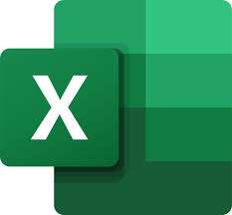A spreadsheet application for organizing and analyzing data in a tabular format

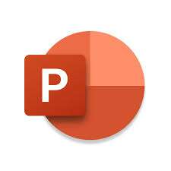

* Microsoft Power Point:

A presentation application for creating and delivering slideshows

* Microsoft Outlook:

An email and calendar application for managing personal and professional communication

* 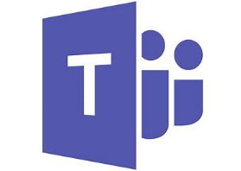Microsoft Teams:

A collaboration and communication application for online meetings, chat, and file sharing

These applications are widely used by students, professionals, and businesses for various purposes. They are also part of the Microsoft 365 suite.

3: Differences between Microsoft 365 and Office 2019

[The difference between Microsoft 365 and Office 2019 is that Microsoft 365 is a subscription-based service that offers cloud-based features and regular updates, while Office 2019 is a one-time purchase that does not include any online services or upgrades](https://bureautique-efficace.com/office-365-vs-office-2019/)[1](https://bureautique-efficace.com/office-365-vs-office-2019/)[2](https://www.howtogeek.com/72454/microsoft-office-vs-microsoft-365-which-one-should-you-buy/).

Some of the benefits of Microsoft 365 are:

* [You can access your files and applications from any device and location, as long as you have an internet connection](https://bureautique-efficace.com/office-365-vs-office-2019/)[2](https://www.howtogeek.com/72454/microsoft-office-vs-microsoft-365-which-one-should-you-buy/).
* [You can collaborate with others in real time using tools like Microsoft Teams, OneDrive, and SharePoint](https://bureautique-efficace.com/office-365-vs-office-2019/)[2](https://www.howtogeek.com/72454/microsoft-office-vs-microsoft-365-which-one-should-you-buy/).
* [You always have the latest version of the Office applications, with new features and security enhancements](https://bureautique-efficace.com/office-365-vs-office-2019/)[2](https://www.howtogeek.com/72454/microsoft-office-vs-microsoft-365-which-one-should-you-buy/).
* [You get additional perks like 1 TB of OneDrive storage, 60 minutes of Skype calls per month, and premium support](https://bureautique-efficace.com/office-365-vs-office-2019/)[2](https://www.howtogeek.com/72454/microsoft-office-vs-microsoft-365-which-one-should-you-buy/)

Some of the drawbacks of Microsoft 365 are:

* [You have to pay a monthly or annual fee to use the service, and if you stop paying, you lose access to your files and applications](https://bureautique-efficace.com/office-365-vs-office-2019/)[1](https://bureautique-efficace.com/office-365-vs-office-2019/)[2](https://www.howtogeek.com/72454/microsoft-office-vs-microsoft-365-which-one-should-you-buy/).
* [You need a reliable internet connection to use the cloud-based features and sync your files](https://bureautique-efficace.com/office-365-vs-office-2019/)[2](https://www.howtogeek.com/72454/microsoft-office-vs-microsoft-365-which-one-should-you-buy/).
* 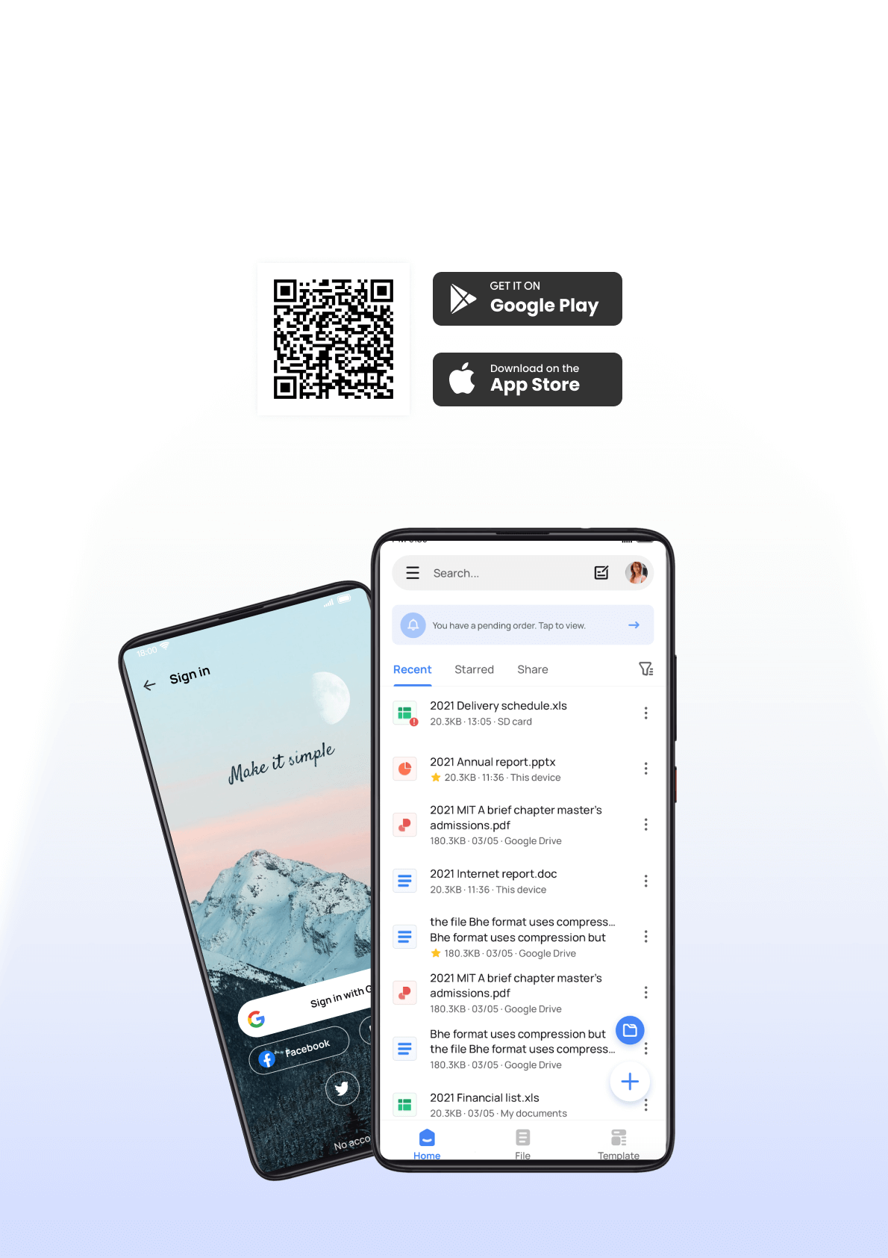[You may not need or want all the features and applications that are included in the subscription](https://bureautique-efficace.com/office-365-vs-office-2019/)[1](https://bureautique-efficace.com/office-365-vs-office-2019/).

Some of the benefits of Office 2019 are:

* [You pay once and own the software forever, without any recurring fees](https://bureautique-efficace.com/office-365-vs-office-2019/)[1](https://bureautique-efficace.com/office-365-vs-office-2019/)[2](https://www.howtogeek.com/72454/microsoft-office-vs-microsoft-365-which-one-should-you-buy/).
* [You can use the software offline, without depending on an internet connection](https://bureautique-efficace.com/office-365-vs-office-2019/)[2](https://www.howtogeek.com/72454/microsoft-office-vs-microsoft-365-which-one-should-you-buy/).
* [You can choose the applications that you need, and avoid paying for those that you don’t](https://bureautique-efficace.com/office-365-vs-office-2019/)[1](https://bureautique-efficace.com/office-365-vs-office-2019/).

Some of the drawbacks of Office 2019 are:

* [You do not get any updates or new features, except for security and bug fixes](https://bureautique-efficace.com/office-365-vs-office-2019/)[1](https://bureautique-efficace.com/office-365-vs-office-2019/)[2](https://www.howtogeek.com/72454/microsoft-office-vs-microsoft-365-which-one-should-you-buy/).
* [You do not have access to any cloud-based services or collaboration tools](https://bureautique-efficace.com/office-365-vs-office-2019/)[2](https://www.howtogeek.com/72454/microsoft-office-vs-microsoft-365-which-one-should-you-buy/).
* [You can only install the software on one device, and if you change or lose your device, you have to buy a new license](https://bureautique-efficace.com/office-365-vs-office-2019/)[1](https://bureautique-efficace.com/office-365-vs-office-2019/)

4: Google Services

Google Services refers to a suite of online applications, tools, and products provided by Google Inc.

These services are designed to enhance various aspects of digital life, offering solutions for communication, productivity, entertainment, and more. Google Services often leverage cloud computing to enable users to access their data and applications from various devices with internet connectivity.

* Different Google Services:

Google provides a diverse range of services, each serving a specific purpose. Here are some key Google Services and their primary functions:

|  |  |
| --- | --- |
| Google Search | The flagship service that enables users to search for information on the internet. |
| Gmail | A popular email service providing users with a secure and efficient platform for electronic communication. |
| Google Maps | Offers mapping and navigation services, providing directions, local business information, and more. |
| Google Drive | A cloud storage service allowing users to store and share files, documents, and multimedia content. |
| Google Calendar | A time-management and scheduling tool to organize events, meetings, and appointments. |
| Google Docs, Sheets, and Slides | Web-based applications for creating and editing documents, spreadsheets, and presentations collaboratively |
| Google Photos: | A platform for storing, organizing, and sharing photos and videos. Google Chrome: A web browser developed by Google known for its speed, simplicity, and security features. |
| YouTube: | A video-sharing platform owned by Google, providing a space for users to upload, share, and view videos |
| Google Translate: | A language translation service that supports text, speech, and image translations |

* Key Differences among Google Services:
* Functionality:

Each Google service has a specific function, addressing different needs. For example, Gmail focuses on email communication, while Google Drive is designed for file storage and sharing. User Interface: While there may be some design consistency across Google services, each has its unique user interface tailored to its specific purpose.

* Integration:

Many Google services are designed to work seamlessly together, allowing users to access their data across various applications. For instance, Google Drive files can be easily integrated into Google Docs for collaborative editing.

* Accessibility:

Google services are accessible across multiple platforms, including desktop computers, smartphones, and tablets, making it convenient for users to use them on various devices.

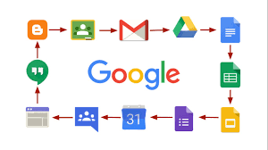

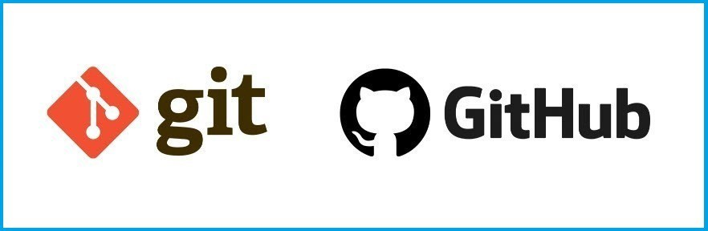5: Git and GitHub

* Definition:

**Git:**

 is a distributed version control system designed for tracking changes in source code during software development. It allows multiple developers to work on a project simultaneously, tracking changes and managing versions. Git provides features such as branching, merging, and the ability to revert to previous states. It is widely used for its efficiency and flexibility in managing collaborative coding projects.

Creation Date: Git was created by Linus Torvalds and was initially released in April 2005.

GitHub:

 GitHub is a web-based platform built on top of Git that provides additional tools and features to facilitate collaborative software development. It offers a graphical interface for managing Git repositories, as well as features for code review, issue tracking, and project management. GitHub serves as a centralized hub where developers can host their Git repositories, collaborate on code, and manage the entire development workflow. It has become a popular platform for open-source projects and collaborative coding efforts.

Creation Date: GitHub was launched by Tom Preston-Werner, Chris Wanstrath, and PJ Hyett in April 2008.

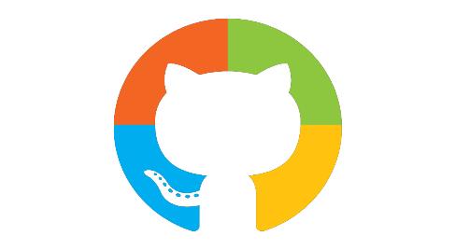6: Microsoft and GitHub

In June 2018, Microsoft announced the acquisition of GitHub,

a popular platform for version control and collaboration among software developers, **for $7.5 billion** in Microsoft stock. The acquisition was completed later that year.

GitHub continues to operate independently, maintaining its brand and platform. However, there have been integrations between GitHub and Microsoft's development tools and services. Microsoft and Google: Historically, Microsoft and Google have been competitors in various technology markets, such as operating systems (Windows vs. Android), productivity software (Microsoft Office vs. Google Workspace), and cloud services (Azure vs. Google Cloud Platform). Despite competition, both companies have also engaged in collaborations and partnerships in certain areas. For example, they have worked together on interoperability between their respective cloud services. GitHub and Google: GitHub, as a platform, is widely used by developers across different ecosystems, including those who develop for Google's platforms (Android, Google Cloud, etc.). Google developers and projects often use GitHub for source code management, version control, and collaboration, just like developers from other companies. It's important to note that the technology industry is dynamic, and partnerships, acquisitions, or other developments may have occurred since my last update in January 2022. I recommend checking the latest sources for the most current information on the relationships between these companies.

7: Conclusion

In conclusion, our exploration of Information and Communication Technologies (TIC) and associated tools has underscored the transformative power these technologies wield in our interconnected world.

TIC has evolved into a cornerstone of modern society, reshaping how we communicate, collaborate, and innovate. The analysis of Google Services has revealed a suite of tools that not only dominate the digital landscape but also profoundly **impact our daily lives**. From communication through Gmail to collaborative work on Google Drive, Google's offerings exemplify the seamless integration of TIC into our personal and professional spheres.

Microsoft Tools, with its robust ecosystem spanning productivity suites, development environments, and cloud services, exemplify the versatility and adaptability demanded by today's dynamic technological landscape. The convergence of tools under the Microsoft umbrella ensures a unified user experience, fostering productivity and innovation. **Git** and **GitHub**, pivotal in modern software development, demonstrate the importance of effective version control and collaborative coding practices. As the backbone of countless projects, their significance extends beyond individual contributions, embodying the collaborative ethos that defines contemporary software development.

Through case studies, we witnessed the real-world impact of TIC, from enhancing healthcare delivery to streamlining business operations. Success stories and challenges alike underscore the ongoing evolution and adoption of these technologies across diverse sectors.

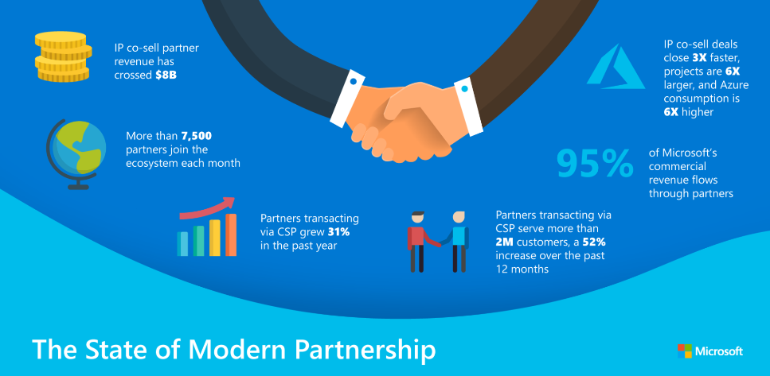The glimpse into future trends indicates a continued trajectory of innovation, with emerging technologies poised to reshape the TIC landscape. As we look ahead, the integration of artificial intelligence, edge computing, and decentralized technologies promises to propel us further into the era of intelligent connectivity. In conclusion, TIC is not just a collection of tools and services; it is a dynamic force shaping the way we interact with information and each other. Navigating this digital landscape requires adaptability, collaboration, and a forward-looking mindset. As we embrace the opportunities and challenges posed by TIC, we position ourselves to thrive in an ever-evolving technological era.